LET US PRAY WITH ALL THE WORLD…

OPENING SONG: In Every Age #464

ANT: We hold in tenderness and prayer the collective suffering of our world at this time.
Psalm 27
The Lord is my light and my salvation—
so why should I be afraid?
The Lord is my fortress, protecting me from danger,
so why should I tremble?

When evil people come to devour me,
when my enemies and foes attack me,
they will stumble and fall.

Though a mighty army surrounds me,
my heart will not be afraid.
Even if I am attacked, I will remain confident.

One thing I ask of the Lord—this I seek most—
to live in the house of the Lord all the days of my life,
delighting in the Lord’s perfections
and meditating in his Temple.

For he will conceal me there when troubles come;
he will hide me in his sanctuary.
He will place me out of reach on a high rock.

ANT: Call us to profound trust in your faithful presence, You, the God who does not abandon.
Psalm 139:13-17
You made all the parts of my body
and knit me together in my mother’s womb.
Thank you for making me so wonderfully complex!
Your workmanship is marvelous—how well I know it.

You watched me as I was being formed in utter seclusion,
as I was woven together in the dark of the womb.
You saw me before I was born.
Every day of my life was recorded in your book.

Every moment was laid out
before a single day had passed.
How precious are your thoughts about me, O God.
They cannot be numbered!

ANT: We ache for ourselves and our neighbors, standing before an uncertain future.
Psalm 63:3-8
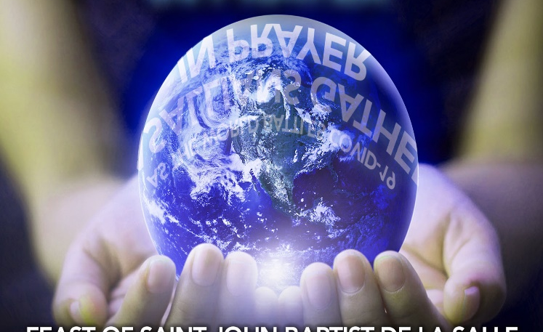
Your unfailing love is better than life itself;
I will praise you as long as I live,
lifting up my hands to you in prayer.

You satisfy me more than the richest feast.
I will praise you with songs of joy.
I lie awake thinking of you,
meditating on you through the night.

Because you are my helper,
I sing for joy in the shadow of your wings.
I cling to you; your strong right hand holds me securely.

READING 1 John 4: 15-19
If anyone acknowledges that Jesus is the Son of God, God lives in them and they in God. And so we know and rely on the love God has for us. God is love. Whoever lives in love lives in God, and God in them. There is no fear in love. But perfect love drives out fear, because fear has to do with punishment. The one who fears is not made perfect in love. We love because God first loved us.

INTERCESSIONS: We focus on the pandemic and its impact on the world and lift these to God.

• For those sick with COVID-19, we ask God to heal, strengthen, and encourage.
• For the vulnerable among us—the elderly and those with compromised immune systems—we pray for health and protection.
• For those who have lost loved ones during this pandemic, asking that God will bring
comfort, peace, and an assurance of His presence.
• For government leaders—local and national—we pray for wisdom and guidance in decisions and for the ability to provide resources and encouraging messages.
• For healthcare professionals caring for the ill and their families, we pray for strength, protection, and courage.
• For researchers who are searching for a cure and treatment, we pray that God will guide and provide answers.
• For first responders in communities where the virus is spreading quickly, asking that God will protect them and their families and give them patience, wisdom, and a gentle spirit when they reach those who are struggling with frightening symptoms.
• For those who battle mental health challenges, anxieties, or addiction, as this time of isolation and staying home with constant negative. We ask God to bring courage and hope and send people to minister through calls, text messages, and kind acts.
• For those unable to get home because of limited flights, we ask God to bring peace and protection where they are and help them get home soon.

• For the media as they provide updates and resources, we ask for wisdom to communicate the
seriousness of the situation without causing panic or fear.
• For those who are laid off or unable to work during this time, we ask God to bring peace and provide for their needs.
- For those who may not have deep family connections, or worse--whose family is the source of abuse, we ask God to protect them.
• For children who are home from school, we ask God to give peace, calm, and even fun memories with their parents while they have more time together than usual.
• For parents with children at home for weeks, we ask God to give ideas, patience, and a focus on making memories with their children and helping them flourish.
• For parents who cannot be home and need to continue working, we ask God to provide ways for their children to be safe and cared for.
• For single parents juggling even more than usual, we ask God to provide support, encouraging friends, and safe childcare when needed.
• For teachers who must now instruct through distance education, we ask God to guide them, give them mental focus, and help their students to truly learn even during challenging times.
• For people working to ensure that others have access to food, medicine, and supplies, we ask that God will provide protection for them and their families.
• For patients needing therapy, tests, or procedures that are now postponed until the pandemic is over, we ask God to give them good health, help them get the tests they need, and fill them with His peace.
• For those who endanger themselves and others by not taking precautions, we ask God to convince them to maintain social distance and help others during this time.
• We pray for our church leaders as they seek ways to keep the church family connected and worshiping together. We pray for technology to work and for people to learn new ways of uniting together.
• We pray for church members to find creative ways to be a light in their communities. Even while social distancing, may we be God’s hands and feet to those in need.
• We pray that God would daily remind us that we can trust God, that God is still in control, that God has a plan and loves us more than we can comprehend.

May we know the Lord’s comfort and strength in our prayer:
“Do not be anxious about anything, but in every situation, by prayer and petition, with thanksgiving, present your requests to God. And the peace of God, which transcends all understanding, will guard your hearts and your minds in Christ Jesus” (Philippians 4:6–7).

Let us give thanks to the Lord, who is good; whose love endures forever. Let us reflect for a moment on what positive things we have found or experienced during this time.
We offer these prayers to our loving, caring Creator, who knows our every need…..
OUR FATHER

CLOSING VERSE:
In every age O God, you have been our refuge;
In every age O God, you have been our strength. (2)

